

**MUSIC STORE ANALYSIS USING SQL**

**OBJECTIVE:** Analyze an online music store’s data to derive insights into customer behaviors, Product popularity and sales trends ultimately improving decision making and optimizing the platform’s performance.

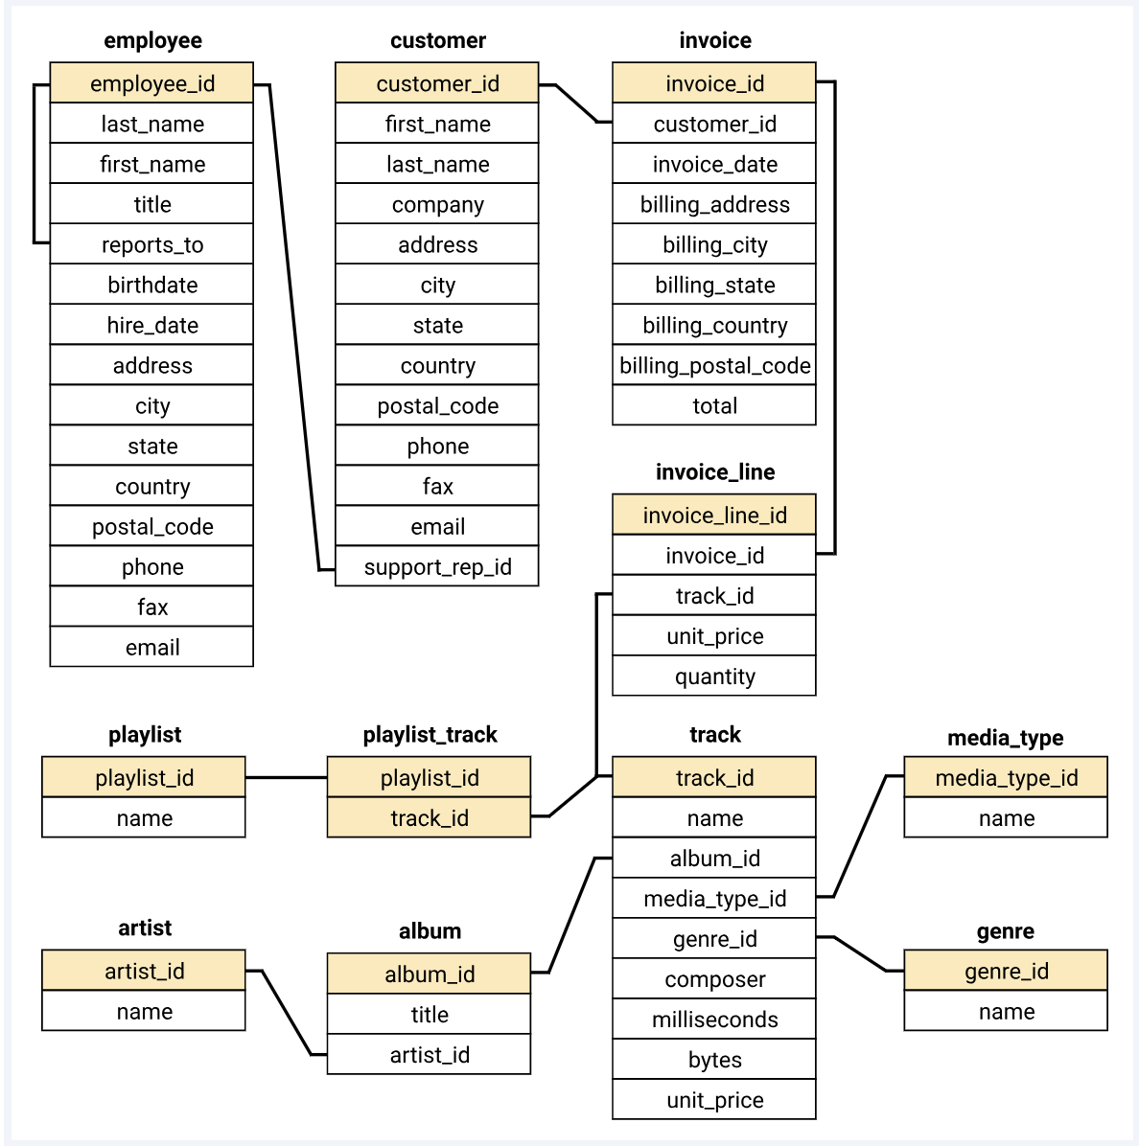

* Questions are divided into three categories based on the complexity of the question- (Easy, Moderate, Advance)

**QUERIES:**

1. **SET – 1 EASY LEVEL**

**Key Learning –** A) Utilizing row number function with order by

B) Aggregating data using count and Group by

C) Basic use of Limit, sum & Join function

**Who is senior most employee based on job title?   
select title, last_name, first_name, levels from employee order by levels desc limit 1;  
**

**Which countries have most invoices?**

**select count(*) as invoice, billing_country**

**from invoice**

**group by billing_country**

**order by invoice desc limit 5;  
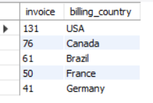  
What are top 3 values of total invoice?**

**select invoice_id, total from invoice**

**order by total desc limit 3;**

**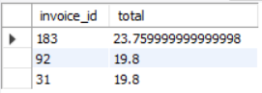  
Which city has best customers? We would like to throw a promotional music festival in the city we made the most money.  
Write a query that returns one city that has highest sum of invoices totals. Return both the city name & sum of all invoice totals.**

**select sum(total) as invoice_total, billing_city**

**from invoice**

**group by billing_city**

**order by invoice_total desc limit 5;  
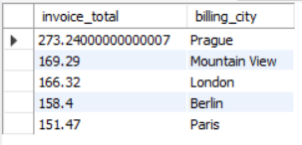**

**Who is the best customer? The customer who has spent the most money will be declared the best customer.   
Write a query that returns the person who has spent the most money.**

**select customer.customer_id, first_name, last_name, sum(total) as total_spent**

**from customer**

**join invoice on customer.customer_id = invoice.customer_id**

**group by customer.customer_id, first_name, last_name**

**order by total_spent desc limit 1;**



1. **SET – 2 MODERATE LEVEL**

**Key Learning-** A) Writing Nested Queries

B) Joining multiple tables and using count and group by

C) Using Subquery with average to filter the data.

**Write query to return the email, First name, last name & genre of all the rock music listeners.  
Return your list ordered alphabetically by email starting with A.**

**SELECT DISTINCT email, first_name, last_name, genre.name AS genre_name**

**FROM customer**

**JOIN invoice ON invoice.customer_id = customer.customer_id**

**JOIN invoice_line ON invoice_line.invoice_id = invoice.invoice_id**

**JOIN track ON track.track_id = invoice_line.track_id**

**JOIN genre ON genre.genre_id = track.genre_id**

**WHERE genre.name LIKE 'Rock'**

**ORDER BY email limit 3;**

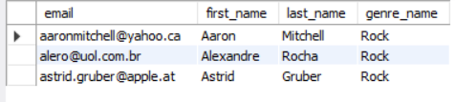

**Let’s invite the artists who have written the most rock music in our dataset.  
Write a query that returns the artist’s name and total track count of the top 10 rock bands.**

**SELECT artist.name,COUNT(artist.artist_id) AS number_of_songs**

**FROM track**

**JOIN album2 ON album2.album_id = track.album_id**

**JOIN artist ON artist.artist_id = album2.artist_id**

**JOIN genre ON genre.genre_id = track.genre_id**

**WHERE genre.name LIKE 'Rock'**

**GROUP BY artist.name**

**ORDER BY number_of_songs DESC**

**LIMIT 10;  
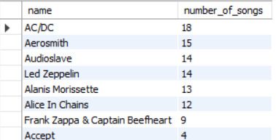**

**Return all the track names that have a song length longer than the average song length.   
Return the name and milliseconds for each track.   
Order by the song length with the longest songs listed first.**

**SELECT name,milliseconds**

**FROM track**

**WHERE milliseconds > (**

**SELECT AVG(milliseconds) AS avg_track_length**

**FROM track )**

**ORDER BY milliseconds DESC limit 5;  
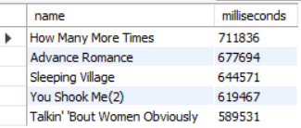**

**SET – 3 ADVANCED LEVEL**

**Key Learning-** A) Using CTE to create temporary result sets for complex queries.

B) Combining CTE, Joins and aggregations.

C) Employing Window functions and developing query to identify top spending customer for each country, handling ties when multiple customers spend same amount

**Find how much amount spent by each customer on artists? Write a query to return customer name, artist name and total spent.**

**WITH best_selling_artist AS (**

**SELECT**

**artist.artist_id AS artist_id,**

**artist.name AS artist_name,**

**SUM(invoice_line.unit_price*invoice_line.quantity) AS total_sales**

**FROM invoice_line**

**JOIN track ON track.track_id = invoice_line.track_id**

**JOIN album2 ON album2.album_id = track.album_id**

**JOIN artist ON artist.artist_id = album2.artist_id**

**GROUP BY artist.artist_id, artist.name**

**ORDER BY 3 DESC LIMIT 1**

**)**

**SELECT**

**c.customer_id, c.first_name, c.last_name, bsa.artist_name,**

**SUM(il.unit_price*il.quantity) AS amount_spent**

**FROM invoice i**

**JOIN customer c ON c.customer_id = i.customer_id**

**JOIN invoice_line il ON il.invoice_id = i.invoice_id**

**JOIN track t ON t.track_id = il.track_id**

**JOIN album2 alb ON alb.album_id = t.album_id**

**JOIN best_selling_artist bsa ON bsa.artist_id = alb.artist_id**

**GROUP BY c.customer_id, c.first_name, c.last_name, bsa.artist_name**

**ORDER BY 5 DESC Limit 5;**

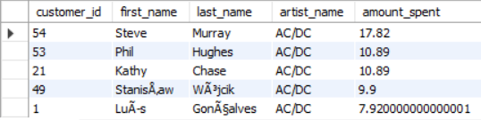

**We want to find out the most popular music Genre for each country. We determine the most popular genre as the genre with the highest amount of purchases. Write a query that returns each country along with the top Genre. For countries where the maximum number of purchases is shared return all Genres.**

**WITH popular_genre AS**

**(**

**SELECT COUNT(invoice_line.quantity) AS purchases, customer.country, genre.name, genre.genre_id,**

**ROW_NUMBER() OVER(PARTITION BY customer.country ORDER BY COUNT(invoice_line.quantity) DESC) AS RowNo**

**FROM invoice_line**

**JOIN invoice ON invoice.invoice_id = invoice_line.invoice_id**

**JOIN customer ON customer.customer_id = invoice.customer_id**

**JOIN track ON track.track_id = invoice_line.track_id**

**JOIN genre ON genre.genre_id = track.genre_id**

**GROUP BY 2,3,4**

**ORDER BY 2 ASC, 1 DESC**

**)**

**SELECT * FROM popular_genre WHERE RowNo <= 1**

**Limit 5;**

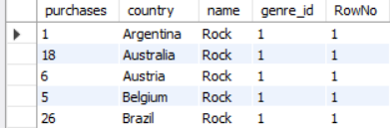

**Write a query that determines the customer that has spent the most on music for each country. Write a query that returns the country along with the top customer and how much they spent. For countries where the top amount spent is shared, provide all customers who spent this amount.**

**WITH Customter_with_country AS (**

**SELECT customer.customer_id,first_name,last_name,billing_country,SUM(total) AS total_spending,**

**ROW_NUMBER() OVER(PARTITION BY billing_country ORDER BY SUM(total) DESC) AS RowNo**

**FROM invoice**

**JOIN customer ON customer.customer_id = invoice.customer_id**

**GROUP BY 1,2,3,4**

**ORDER BY 4 ASC,5 DESC)**

**SELECT * FROM Customter_with_country WHERE RowNo <= 1**

**Limit 5;**

